10th July 2017

Response to Reviewer Comments

Do Digital Technologies Enhance Anatomical Education?
Zoe Pringle and Paul M. Rea

Dear Dr Pritchard and PESTLHE,

First and foremost a huge thank you, to you and the PESTLHE team for organising the review of our manuscript. The reviewers comments have been most helpful in hopefully improving the manuscript ready for publication in PESTLHE.

We would like to extend out a warm note of thanks to the reviewers for their suggestions and comments in helping improve this manuscript. Their expertise and opinions have been invaluable and constructive. We have responded below on a point-by-point basis to their comments, and our comments/responses are in bold.

Reviewer A

Figure 2: why is this displayed using a bar chart? I'm not sure this is
helpful - a simple table might be better, in order for the reader to quickly
see the numbers and comparisons

We have used a bar chart format to allow the reasder to easily identify the categories and pro[portions of articles. This allows for a quick compariosnn between the different categories. The whole numbers are above each bar to allow further clarifivctaiopj of absolute numbers. In addition the numbers, incluing percentages are also within the text shoul;d the reader require further details.

Figure 3 and 4a: again, I'm not sure if the data is displayed in the best
way as the y axis is always 'number of ...' rather than '%' and so the
reader is left to calculate the findings in their head so that they can
compare the different columns to work out what's happening.

These figures allow the reader to identify the whole numbers in each category and again allows for an easy comparison between different categories. The percentages are within the text, and the results and discussion places the results in context of the other data presented. Should the reader wish to examine the data further and compare a variety of features outside the scope of this article, they also have access to that dataset.

Reviewer B

The aims of the study could be more precise, aimed at whether digital
tools are effective means of teaching in anatomical education rather than to examine what the general consensus about them is. This would make it a more compelling piece of work.

This is a very valid point, and as such, we have simplified and made the aim much more specific by changing the end of the introduction to:

“Therefore, the aim of this study is to examine the current literature to identify if digital tools are actually effective in anatomical education.”

The methodology used to select the publications for inclusion in the study are not clear. The tables that should show the keywords that were used in the article searches and how they were categorised into ‘Pro’, ‘Neutral’ and ‘Against’ are missing from the manuscript. It makes it impossible to assess the criteria used.

We apologise for not including the Tables (1 and 2) and have now attached them. That should allow an easier understanding of the criteria used in this study, again please accept our apologies.

It would be good to have an overview of the evaluations used in the
articles assessed as having been ‘empirically tested’ – are they via
class tests, summative tests or online quizzes? A broad overview will
suffice.

Again, this is a very valid point and we completely agree with this, and have added the following statement in the text:

For those articles that were identified as being empirically tested, there was a mixture of both qualitative and qualitative methods used for data collection. Qualitative data was collected via free text boxes and survey questions. Quantitative data was collected via scales on questionnaires, typically on a Likert scale, and assessment of change of marks and grades using multiple choice question assessments in an examination format.

The discussion is very long and could be much more concise. Much of the
second half reads as a review of different digital technologies rather than
a discussion of the reported results in the context of the literature. It
also includes data that is not expressly detailed in the ‘Results’. If
it is to be retained, then that data should be moved to the appropriate
location in the manuscript.

We have moved results presented here from the discussion to the results section. We have discussed the data and results more broadly and presented the key facts in relation to each of the categories examined.

The language needs greater precision. For instance, the author(s) refer
to the articles being empirically tested or not tested, whereas it is the
tools and teaching methodologies which are being tested.

We have clarified and further explained this under the Data Analysis section by changing to the following:

“From the articles identified, we then separated them into empirically tested (ET) and non-empirically tested (NT) based on the tools and teaching methodologies, and if their use was assessed as to their effectiveness (empirically tested), or not (non-empirically tested).”

The author(s) should consider placing the web-based resources detailed
in the introduction into a second appendix. Placing them in the main text as
references makes the text difficult to read and understand.

We feel that it is essential to list some of the web-based resources to highlight the huge range that is available. What is presented here represents a snap shot of what is currently available, and even at this, is only a small representation. It is felt that the reader needs to be aware of the explosion onto the market and literature of some of the key products and methodologies.

In Figure 4, please use the same colour for the categories in panels a
and b – it makes interpretation much easier for the reader.

We feel, as in Figure 2, that it allows a more visually engaging representation of our data and makes sure that the data is not presented in a bland fashion which may result in the reader missing details.

Yours truly,

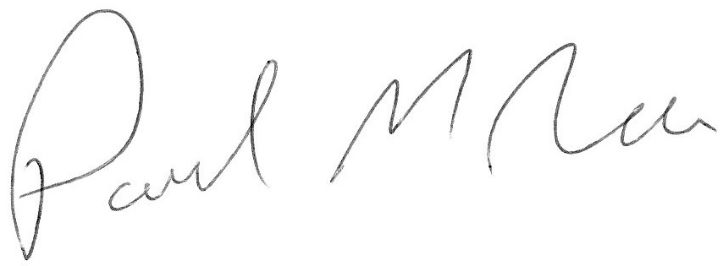

Dr Paul M. Rea
Senior Lecturer
University of Glasgow

