Assessing Final-Year Practical Work Through Group Projects

Abstract
The final year project is a valuable research experience for undergraduates and can be one of the most rewarding aspects of their degree course. For BSc students it can be difficult to achieve meaningful results in the limited time available, as many projects involve long lead-in times before experimentation can begin. To address this, the Department of Chemistry at the University of Reading has recently explored the use of group projects for final year practical work. Students work in teams of 3 to 5 and are presented with a research problem to investigate. These are genuine projects where the answer is unknown and the work open-ended. The students must work together to investigate the problem, dividing the work and sharing results in a manner that more closely resembles project working in industry. The students’ output is assessed through a variety of means including a group presentation and report. The projects were successful, with all students completing the work to a satisfactory level and developing strong team working skills. This paper will try and outline some of the issues that we faced, and the steps that we have taken to alleviate some of these issues in the coming years.

Keywords: group-working, team-work, practical, UV spectrometer, group assessment

Background:
Chemistry is a practical subject and a large element of an undergraduate chemistry course is the practical work. Such is the importance of practical work, the Royal Society of Chemistry (RSC) states that it is an essential component of a degree programme, and that without providing various levels of practical work and a minimum number of laboratory hours in a degree programme, the degree programme will not be accredited (RSC accreditation, 2014).

Upon completion of a bachelor’s degree, the RSC expects that students have: a broad and balanced appreciation of key chemical concepts; a range of practical skills so that they can understand and assess risks and work safely in the laboratory; the ability to apply standard methodology to the solution of problems in chemistry; and the knowledge and skills base which leads to graduate employment or to further study. In terms of specific practical skills, the practical work must be challenging; include a variety of laboratory-based components; rigorously assessed; and should contain at least 300 timetabled hours (for a bachelor’s degree). An accredited degree must also contain some investigative work, contributing to at least 25% of the final-year workload, so students consolidate and extend their knowledge of chemistry. This project work is usually completed as a research project in a laboratory. At the University of Reading, the timetabled allocation for bachelor’s projects is 2 days per week in the Autumn term (amounting to approximately 180 hours and 40 credits).

With the recent increase in student numbers, the provision of individual final-year practical projects for bachelor’s students has become increasingly demanding. Managing the transition from a second year practical class, with a finite degree of student independence but in a semi-controlled environment, to truly independent enquiry-based working requires significant resource. In addition, we felt that individual projects did not fully prepare students for life after university because there was no team-based element present and a vital skill required for life in the workplace is to be able to work efficiently and effectively as part of a team.

To combat these issues it was decided that the final-year project would be carried out as a group-based research project, with an emphasis on peer-assisted learning. Research has shown that if used carefully, peer-assisted learning is an excellent teaching tool because it provides a safe, supportive learning environment, encourages students to express their thoughts and ideas, can be a valuable way to improve student achievement, and can contribute to life-long learning (Blumenfeld, Marx, Soloway & Krajcik, 1996; Tien, Roth & Kampmeier, 2002; Lyle & Robinson, 2003; Towns, Kreke & Fields, 2000). It was hoped that using the group-project approach in the final year of the bachelors degree course would provide all of the above advantages, as well increase student engagement, facilitate the transition from dependent to independent learner, and prepare students for work after graduation because as the “team-based” approach more closely mirrors professional practice.

Assessment:
An assessment scheme was devised such that overall the assessment included a written report, a team presentation, laboratory notes book/journal and team-working practice with the majority of the marks resting upon the written report. There was also an element of peer review and students were able to assess each others performance.

Group Projects:
Prior to term starting, students were asked to select their top two preferred areas for investigation (inorganic, organic, physical and analytical) and were divided into teams of between 3 and 5 students, according to their preferred subject area. Students were tasked with undertaking two research projects in the autumn term, potentially in two different teams, with each project lasting five weeks. The first project was mainly a formative exercise and was in students’ second-choice of research area. The second project was in the students’ first-choice of research area. The rationale behind this was that students would be able to undertake their first project without the pressure of assessment, and would be able to make mistakes that would not adversely affect their final grade. After the first project, students would present their work to both academic staff and their peers, and receive feedback. It was intended that this feedback would feed forward into the next project that students completed.
The projects themselves were in a broad array of areas, and a description of each was written such that they fitted into one of the traditional areas of chemistry (inorganic, organic, physical and analytical), although this was not always possible. Determining tasks that would be suitable for group projects was one of the hardest aspects of the whole exercise. Some work, funded by a small university funded grant, was carried out by two Year 4 students over the summer prior to the first iteration of group projects. The students investigated the viability of the different project ideas and prepared some starter guidance for students in each of the topics. Reports in the Journal of Chemical Education provided a rich source of ideas for potential group projects, and with a little thought, the published procedures were altered for our use.

The projects in the first iteration were as follows:
- Organic: determining the main components of lavender oil
- Organic: C-H activation/functionalisation using Co and Fe (Roane & Daigulis, 2016)
- Inorganic: Investigating various novel ligands and their position in the spectrochemical series (King, 1971).
- Physical: Design and construction of a UV spectrometer (Bougot-Robin, Paget, Atkins,& Edel, 2016)
- Analytical: Investigation into the Finkelstein reaction using ¹H NMR (Mobley, 2015)

Example of a project: designing and building a spectrometer
For the Physical Chemistry group project the students were set the general task of designing and building a spectrometer, powered by a low-cost Raspberry Pi computer. This broad and flexible remit gave them considerable scope to shape the project and the direction it took. They were provided with the Raspberry Pi computer (which had no relevant software installed), basic optical and electronic components (a light sensor, a white LED, an analog-digital convertor, diffraction grating, cuvette cells to hold samples, breadboards, jump lead connector cables), and a “Getting Started with Raspberry Pi” manual (Raspberry Pi, 2017; Richardson & Wallace, 2012). The member of staff running the project agreed to 3D print components from *.stl files provided by the students if required, but the students were encouraged to be imaginative in thinking of other building materials (cardboard, cloth, plastic bottles etc).

Students had to take responsibility for looking online or in the library to find their own resources in order to be able to code in Python, run a Raspberry Pi, read voltages, and switch on an LED. They also had to find their own designs for their spectrometer, and suitable chemical systems to test the spectrometer. For this they were encouraged to undertake literature searches within suggested journals, for example the Journal of Chemical Education, and were provided with a few key references to similar tasks such as the Lego Spectrometer [Raspberry Pi, 2017b; Wang, Rodríguez Núñez, Maxwell & Algar, 2016; Asheim, Kvittingen, Kvittingen & Verley, 2014; Martin, 1990)

The students were clearly motivated by the creative freedom and input the project allowed them. For example, the supervisor had originally envisaged a spectrometer operating at a fixed angle (wavelength), which could perhaps be varied manually, as in literature education examples [Bougot-Robin, Paget, Atkins,& Edel, 2016; Albert, Todt & Davis, 2012). However, one group felt that it would be better to have an automated design, with the angle selected by moving a motor. They explained this to the supervisor who ordered a low-cost servo motor for the project, which the students learned to control with the Raspberry Pi and incorporated into their spectrometer. This aspect added a more exciting dynamic quality to the project because the supervisor needed to be prepared to stay one step ahead of the students, in this case, researching in real time which motor technology is feasible in terms of cost and coding simplicity. The motor was ordered from Amazon, with next day delivery specified, to ensure that it minimized any delay in the students’ project progress.

During the investigation, students were encouraged to break down the overall project plan into individual tasks with testable outcomes. For example: “Student A will demonstrate that it is possible to programme the Raspberry Pi to read light sensor values via the analog-digital convertor; Student B will code the Raspberry Pi to move the motor to different requested input angles; Student C will find a suitable dye and concentration range that gives a linear absorbance at a certain wavelength using a commercial spectrometer”. Further tests then built up the complexity of the project, for example investigating the linear response of Student C’s dye using Student A’s light sensor at a fixed wavelength by manually setting the diffraction angle. The final spectrometer design is shown Figure 1.

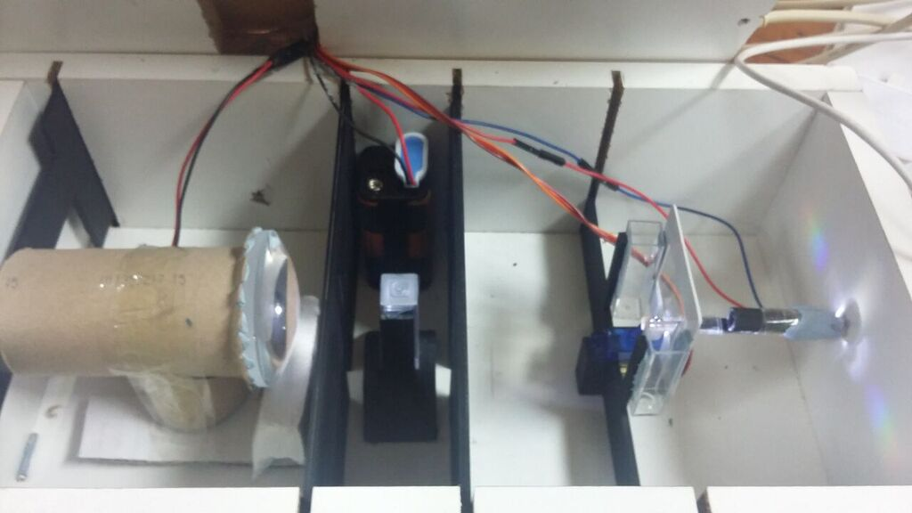
Figure 1: UV spectrometer that the students built in 2015/16.

Encouraging the students to come up with the breakdown and testable milestones themselves provides a number of pedagogical advantages. Firstly, it trains students in sensible experiment design and rational logical approaches to trouble-shooting if their experiment/suggestions are unsuccessful. Secondly, it encourages students to think about team-working, planning, milestones, delegation of responsibility, and therefore to develop project management skills that are transferrable to the wider workplace beyond science. Thirdly, it meant that even though the students were working in groups, each had clear ownership of a defined aspect of the project with its own successes or failures, and so did not lose the motivational aspects that can be present within individual projects. This ownership and accountability also helps with employability, as the student could point towards their own contribution, for example, in an interview. Finally, it helped align with assessment methods; students were further motivated by the fact that they would be required – in their assessed presentations and reports – to show their individual contribution and to provide evidence for the extent of its success. To emphasise this point, they were reminded that they were to take responsibility for making sure they would have results to do this even if their colleagues failed in the other aspects of the project.

Conclusions and Recommendations
The first iteration of group projects (2015/16) provided us with a great deal of information about how best to run these projects in subsequent years. Student evaluation of the projects was carried out by questionnaire at two points during the projects and these were triangulated by small discussion groups. The main findings are outlined below.

The main outcome was that students would have preferred a single large project rather than two shorter ones. The reason given was that five weeks was the approximate amount of time that students needed to acclimatize to the project. At this point students felt like they were just beginning to understand the concepts, and were able to begin to contribute something useful. Having to finish the first project and switch to another one at this time actually had a negative impact, and students felt they were regressing rather than progressing.

A further finding was that a strong academic lead for each project is crucial as the academic provides a key role in the motivation of students, organization of the team and driving the work forward. Without this input a lack of student engagement was observed, which ultimately resulted in less project-work being completed. Weekly meetings with the academic supervisor were essential and ensured that all students felt they were contributing to the project. In addition, it was found beneficial for the team to set milestones (either weekly or half-termly, the exact nature depended upon the project) because meeting targets provided excellent external motivation. We noticed that it made a large difference to student engagement and motivation if they achieved a positive result in the first few weeks of the project. As well as guiding the team during the project, it was also necessary for the supervisor to do some up-front planning, for example ordering chemicals, or ensuring the availability of specialist equipment.

Lack of student engagement among team members was occasionally an issue, and in these situations it was essential that students kept their academic supervisor aware of the situation so they could intervene if necessary. Although group work is an integral part of the Bachelor’s degree at Reading and students are used to working in teams, because the project contributes a large proportion (22%) of the marks used for classification, it was essential that supervisors were aware of any difficult situations arising. For some students the project mark can be instrumental in taking a student over a grade boundary, and frequently students are aware of this so invest highly in the activity, and individually contribute more than the average. In these cases it is imperative that the academic is aware of any imbalance and has the opportunity to award credit accordingly. This was quite difficult within the first assessment schedule used for the group projects, where teams wrote a collaborative report, albeit with individual sections. Students themselves were asked to peer evaluate each other’s contributions but, despite this, we felt a joint report was not the best way to assess individual students. This uneven distribution of contributions was further exasperated by the more organized students wanting to complete and submit the report in good time before the exam period whereas the less conscientious students with a more relaxed approach effectively held back completion of the assignment.

Overall, our initial experience of using group projects for final year BSc students was successful. However we have made some adaptations for the second year of group projects to address student and staff feedback. Students reported that they enjoyed the freedom of the open-ended work, and the larger pool of ideas provided by working collectively as part of a team. In our second iteration, students will be given one ten-week project rather than two five-week projects to address their comments about project length. Students will be asked to write a single report rather than a group report which will clarify assessment and remove dependence on less motivated team members. In this report they will discuss their own findings and put them in context with those of the group. Students will be required to draw conclusions from the group’s work as a whole, rather than just their own results. Further results and observations will be reported in due course.

References

Albert, D. R., Todt, M. A. & Davis, H. F. (2012). A Low-Cost Quantitative Absorption Spectrophotometer. J. Chem. Educ., 89(11), 1432-1435.

Asheim, J., Kvittingen, E. V., Kvittingen, L. & Verley, R. (2014). A Simple, Small-Scale Lego Colorimeter with a Light-Emitting Diode (LED) Used as Detector. J. Chem. Educ., 91(7), 1037-1039

Blumenfeld, P. C., Marx, R. W., Soloway, E., & Krajcik, J. (1996) Learning with peers: From small group cooperation to collaborative communities. Educational Researcher, 25(8), 37-39.

Bougot-Robin, K., Paget, J., Atkins, S. C., & Edel, J. B., (2016) Optimization and Design of an Absorbance Spectrometer Controlled Using a Raspberry Pi To Improve Analytical Skills. J. Chem. Educ., 93(7), 1232-1240.

King, H. C. A. (1971) Preparation and properties of a series of cobalt(II) complexes. An undergraduate laboratory investigation. J. Chem. Educ., 48(7), 482-484

Lyle, K. S. & Robinson, W. R. (2003) A Statistical Evaluation: Peer-led Team Learning in an Organic Chemistry Course. J. Chem. Educ., 80(2), 132-134.

Martin, J. D. (1990) A Visible Spectrometer. J. Chem. Educ., 67(12), 1061-1062

Mobley, T. A. (2015), NMR Kinetics of the SN2 Reaction between BuBr and I−: An Introductory Organic Chemistry Laboratory Exercise. J. Chem. Educ., 92(3), 534-537

Raspberry Pi (2017) Raspberry Pi Documentation (website). Accessed 10 January 2017 from: https://www.raspberrypi.org/documentation/

Raspberry Pi (2017) Raspberry Pi Documentation (website). Accessed 10 January 2017 from: https://www.raspberrypi.org/blog/lego-spectrometers/

Richardson, M. & Wallace, S. (2012) Getting started with raspberry PI. O'Reilly Media, Inc.

Roane, J., Daigulis, O. (2016) A General Method for Aminoquinoline-Directed, Copper-Catalyzed sp² C–H Bond Amination. J. Am. Chem. Soc., 138(13), 4601-4607

RSC (2014), Accreditation of Degree Programmes (PDF). Retrieved 10 January 2017 from: http://www.rsc.org/Education/courses-and-careers/accredited-courses/

Tien, L. T., Roth, V., & Kampmeier, J. A. (2002) Implementation of a peer-led team learning instructional approach in an undergraduate organic chemistry course. J. Res. Sci. Teach., 39, 606-632

Towns, M. H., Kreke, K., Fields, A. (2000) An Action Research Project: Student Perspectives on Small-Group Learning in Chemistry. J. Chem. Educ., 77(1), 111-115

Wang, J. J., Rodríguez Núñez, J. R., Maxwell, E. J., & Algar, W. R. (2016) Build Your Own Photometer: A Guided-Inquiry Experiment To Introduce Analytical Instrumentation. J. Chem. Educ., 93(1), 166-171

